**HYPERLOOP**

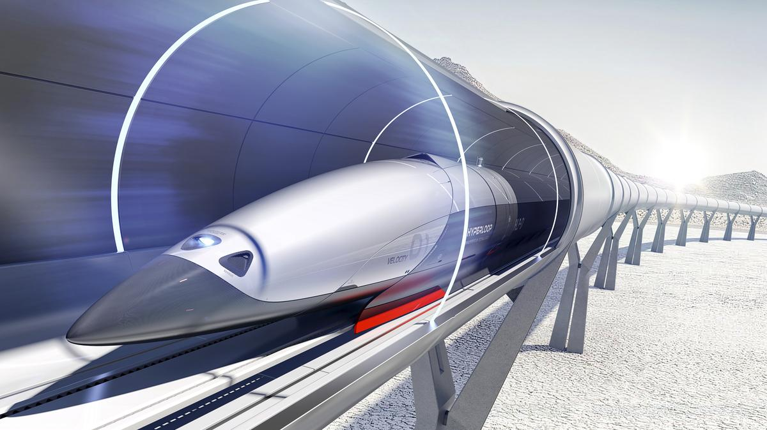

Hyperloop’s pods, which travel on a bed of air, travel at around six times the speed of an average modern train. Musk, who made the idea open-source to encourage others to develop it, wants each route to be fully solar-powered, using panels along the tube that carries each pod. Tesla and SpaceX chief [Musk](https://www.redherring.com/top-story/elon-musk-down-not-yet-out/) actually drew from an idea devised by British inventor George Medhurst in 1799.

**Questions**

*1. Did you know that Musk is not the first person to suggest air pressure-driven transportation?*

*2. What did George Medhurst devise?*

*3. Do you know any developers of the idea in Spain?*

# Video: Hyperloop Dubai Vision 2020 : Biggest Revolution In Economy & Technology !

<https://www.youtube.com/watch?v=XHbXSY0A0aU>

Fill in the gaps with the adequate preposition: to (1), of (2), in (3), by

Hyperloop is expected to be built .... Dubai .... 2020. It will be the biggest revolution .... economy and technology. The global growth .... e-commerce is driving a consumer behaviour shift where goods and services are delivered rapidly, immediately. DP World and Virgin Hyperloop One have partnered .... realize the next leap .... transport and make Hyperloop a reality pushing the boundaries .... innovation, having the courage to do something different. It's on-demand, energy-efficient and safe.

**Questions**

How fast does it travel? At what cost?

How is it powered?

Is the Hyperloop designed to transport only passengers?